EntrepreNeuro
from neuroscience to innovation

Application Reference Document:

The following questions are to help you prepare your application. All applications must be completed through our online application form: https://forms.gle/TUc2yK3a5Z5JzsCY6

Fill in the information below to apply for the Campus Alberta Neuroscience (CAN) EntrepreNeuro Program. Complete applications are due by Friday, September 24th, 2021 by 5:00pm Mountain Standard Time (MST). Please note that only shortlisted applicants will be invited into the program.
Short answer question responses:
- For those not applicable, feel free to answer “N/A”
- Feel free to use bullet points
- Do not feel obligated to have the maximum allowable words
- Brevity can help breed clarity
Please ensure that you have fully read and understood the CAN EntrepreNeuro Program details prior to filling out this application form. Please note that you will not be able to save your application during the submission process.

Primary Applicant Information:
- First Name:
- Last Name:
- Email:
- Phone number:
- University:
- Company Name (if applicable):
- Position:
- How do you self-identify? (Main Applicant)
  - Student
  - PI (Principle Investigator)
  - Entrepreneur
  - Researcher
  - Other:
- Are you a Campus Alberta Neuroscience member? You must be a member to apply! Becoming a member is free and easy at https://www.albertaneuro.ca/register/
  - Yes
  - No
- Is there a co-applicant and/or another team member?
A maximum of 2 team members can attend a workshop session. The workshop attendance throughout the program can be shared among the team.
  - Yes
  - No

Co-Applicant Information:
- First Name:
- Last Name:
- Email:
- Phone number:
- University:
- Company Name (if applicable):
- Position:
- How do you self-identify? (Co-Applicant)
  - Student
  - PI (Principle Investigator)
  - Entrepreneur
  - Researcher
  - Other:
- Is there another co-applicant and/or team member?
A maximum of 2 team members can attend a workshop session. The workshop attendance throughout the program can be shared among the team.
  - Yes
  - No

Co-Applicant Information:
- First Name:
- Last Name:
- Email:
- Phone number:
- University:
- Company Name (if applicable):
- Position:
- How do you self-identify? (Main Applicant)
  - Student
  - PI (Principle Investigator)
  - Entrepreneur
  - Researcher
  - Other:

Experience
Have you (or your co-applicants) led a start-up before?
  - Yes
  - No

What other programs have you attended or participated in for entrepreneurship and innovation?

CAN Entrepreneurship Seed Grant
Have you previously applied for a CAN Entrepreneurship Seed Grant?
  - Yes
  - No

Neuroscience Innovation
Which of the following themes best describes your project?
  - Depression
  - Dementia
  - Multiple Sclerosis
  - Neuroimaging
  - Pain, Cannabis, Opioids
  - Spinal Cord Injury
  - Mental Health
  - Health
  - Artificial Intelligence
  - Computational Neuroscience

What is your project's/company's name?

Does your project/company have a website/URL? If so, please include a link to it?

How would you describe your project in 1 sentence (Elevator Pitch)?

The Stages of Innovation and Entrepreneurship (image reproduced from Alberta Innovates)
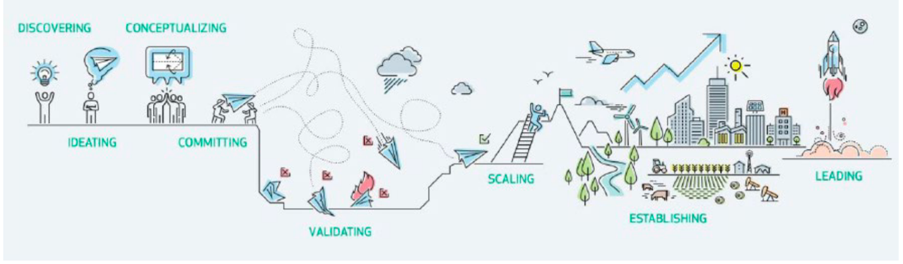

At what stage is your innovation project at?
- Discovering (Need Identification)
- Ideating (Idea Generation)
- Conceptualizing (Proof of Concept)
- Committing (Proof of Feasibility)
- Validating (Demonstrating Value)
- Scaling (Growing)
- Establishing

What neuroscience and/or mental health related challenge does your project address and what work (e.g., research, prototyping, etc.) has been undertaken to date? (1-300 words)?

What makes your project (e.g., product or service) unique in the market (Up to 300 words)? Please provide background on your competitors, their location and focus, and how your project differentiates itself.

What are you looking to get out of the EntrepreNeuro program?

Are you currently looking for funding? If so, how much and what avenues have you pursued?

What is your and/or your teams’ expertise and experience (e.g., technical/scientific expertise, leadership capacity, etc.) to carry out the proposed project (Up to 300 words)?

What is your exit strategy (1-5 sentences)? An exit strategy is an entrepreneur's strategic plan to sell or pass on their ownership in a company to investors or another company.

